ATTACHMENT P

AIR 5409 Security Classification Grading Document

Version (DRAFT)

Document Number: AIR5409-015
Identification and Release Information
Document Location
The master copy of this document is held by ALGWD.
Revision History

Date of this Revision |  | Expected Date of Next Revision:

Revision date | Version Number | Summary of changes | Changes Marked

Sponsor
This document is sponsored by:

Version | Name | Position | Signature | Date
7.1 | SQNLDR G.McKee | A/DDCE

Drafts
This document is drafted by:

Version | Name | Position | Signature | Date
7.1 | FLTLT B. Birrell | AAB ENG2
Endorsements
This document is endorsed by:

Version | Name | Position | Signature | Date
7.1 | SQNLDR D.D. Sgalippa | AAB PEM
Approval
This document is approved by:

Version | Name | Position | Signature | Date
7.1 | Mr T. Stamp | ALGWPD
Distribution
This document has been distributed to:

Version | Name | Position | Date of Issue

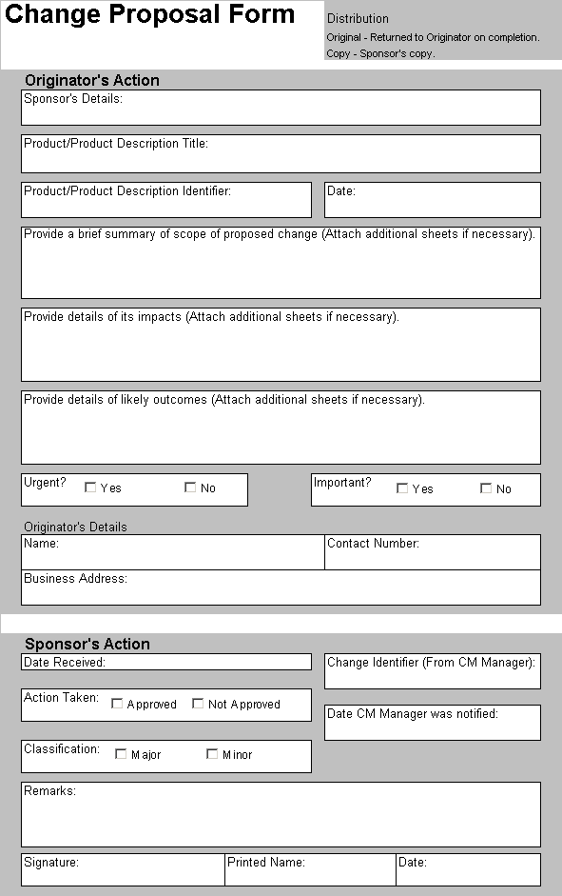
Table of Contents
1. Introduction 1-1
1.1 Purpose 1-1
1.2 Scope 1-1
1.3 Structure 1-1
1.4 References 1-1
1.5 Storage and Printing 1-1
1.6 Amendment and Review 1-1
2. USE OF THE GRADING DOCUMENT 2-1
2.1 Introduction 2-1
2.2 General Classification Guidelines 2-1
2.3 Test and Reports 2-1
2.4 Release of Information 2-1
3. SECURITY CLASSIFICATION GUIDANCE FOR AIR 5409 3-1
3.1 Security Classification Levels 3-1

List of Annexes
ANNEX A TO THE SCGD – CLASSIFICATION GRADINGS A-1

List of Figures
Figure 1 : Classification gradings for Weapon and associated MPS A-1

Introduction

Purpose
    - The purpose of the Security Classification Grading Document (SCGD) is to provide the Air Launched Guided Weapons Project Directorate (ALGWPD) with direction determining appropriate security gradings for Project AIR 5409 developed and controlled products.

Scope
    - This SCGD is applicable to all products developed for and/or controlled by the ALGWPD in the progression of project AIR 5409.

Structure
    - This SCGD is structured as follows :
- Use of the Grading Document
- Introduction
- General Classification Guidelines
- Test and Reports
- Release of Information
- Security Classification Guidance for AIR 5409
- Annex A to the SCGD

References
    - The following references are relevant to this SCGD:
- DSM Part F – Security Framework for Competitive Tendering and Contracting (CTC), Chapter 13 Project Security – Example of a SCGD Format
    - All acronyms and significant terms used in this SCGD are contained in the AIR 5409 Glossary and Acronym List. All significant terms are identified by capitalisation of the first letter of the term.

Storage and Printing
    - The “read only” master of this SCGD is stored electronically by ALGWD.
    - All hard or electronic copies of this SCGD or its Product Description are to be marked as “Uncontrolled Document”.

Amendment and Review
    - This Plan and its associated information are to be formally reviewed and amended at the end of every phase and in all cases, at least quarterly until contract signature.
    - The AABSM is responsible for ensuring that reviews are completed in a timely manner.
    - The review and amendment process is to include any improvements and lessons learned citied in the Lessons Learned Log.

USE OF THE GRADING DOCUMENT

Introduction
    - This document outlines the methods used to classify any material associated with AIR 5409.

General Classification Guidelines
    - All information associated with AIR 5409 is to be classified in accordance with this SCGD.
    - The SCGD identifies the major systems and sub-systems associated with the AIR 5409 capability and assigns a blanket classification to the various project aspects related to each system component. The SCGD shall be used for the following purposes:
- To determine the physical security arrangements required to handle equipment and documentation associated with physical security arrangements required for each system component;
- To classify the complete system; and
- To classify sub-systems.
    - Blanket system classifications have been provided at Annex A to this document. The table is aimed at providing a base classification level for information, equipment or sub-systems contained within the broad system definition.
    - During development of a Configuration Item, an individual may wish to alter the classification from that given at Annex A. To do so, justification needs to be given to the appropriate PO section head.
    - If the classification level of the Configuration Item is altered from that at Annex A, the AIR 5409 SM or AIR 5409 PEM will need to be advised so that appropriate changes, if required, can be made to the classification matrix at Annex A.
    - Classification of documents should be to the lowest possible grading, consistent with the document’s content, to enable ease of handling and transfer.
    - Contractors will be required to assign security classifications in accordance with the SCGD. For classification assistance, the AIR 5409 PO should be contacted at the earliest possible convenience.

Test and Reports
    - Normally the security grading of tests and associated reports will be the same as that assigned to the most highly graded aspect of the particular equipment which is revealed. Test equipment is to be graded on merit according to the classification of the information revealed.

Release of Information
    - Information pertaining to AIR 5409 will be released at the project manager’s discretion. It is expected that the only information that will be released to the public is information already in the public domain or that is not Commercial-in-Confidence from the OEM.

SECURITY CLASSIFICATION GUIDANCE FOR AIR 5409

Security Classification Levels
    - The security classification levels are detailed at ANNEX A TO THE SCGD – CLASSIFICATION GRADINGS

ANNEX A TO THE SCGD – CLASSIFICATION GRADINGS
Figure 1 : Classification gradings for Weapon and associated MPS

 | Guidance System | Target Parameters | Performance | Internals (Hardware/Software etc)
BIP-E Guidance kit | UNclassifed except:  CONFIDENTIAL: GPS anti-tamper coating  SECRET  GPS SAASM functions/capabilities  Classify IAW NAVSTAR GPS SPG  GPS Anti-Jamming (AJ) functions/capabilities  Classify IAW NAVSTAR GPS SPG |  | unclassifed except:  SECRET  - IR Signature  - Radar cross section signature  - Specific GPS jamming modes and techniques, their effectiveness and test results  - Electromagnetic environment (EME), tactical (HAVE NOTE) Any RF outside specific ECM  - Performance degradation details which identify weapon operational performance deficiency or degradation | UNCLASSIFED except:  UNCLASSIFIED  Unkeyed end item, complete weapon (SAASM and non-SAASM GPS receivers)  Keyed end item, complete weapon (SAASM GPS receiver)  SECRET  Keyed end item, complete weapon (non-SAASM GPS receiver)
BIP-E PLGS |  |  | unclassifed | UNCLASSIFED
BIP-E ER Kit |  |  | unclassifed | UNCLASSIFED
 | Static Data | Internals (Hardware/Software) | Target Parameters
MPS |  | Unclassifed (unless source of information in software is classified by other SCGDs)
 | Specifications | Acquisition/ Strategy | Project Management | Technical/Engineering | ILS | Finance
PO Configuration Items (Documentation) | Up to Confidential | Restricted | Unclassified | Up to  Secret | Unclassified except:  secret  Inventory  CONFIDENTIAL  Annual Training Rate | Commercial-in-Confidence
 | # Kits to be Purchased | Test Data
Administrative Data | Unclassified except:  secret  - Total number of kits procured | Unclassified  International telemetry data stream
 | Carriage and Release Parameters | OFP S/W | Other Integration
Aircraft | Restricted | UNCLASSIFIED

