Supplier NN Training & Resources Tip Sheet

Access to SQIS
If you, or appropriate Supplier colleagues, do not have access to SQIS, please contact the following:
- With an existing BEMSID/Account: Reach out to your Supplier Quality Representative (SQR)
- Without a BEMSID/Account: Contact your Procurement Agent
Note: Regular logins are required to maintain access. Please follow instructions when notified to maintain SQIS access.
NN Basics
An NN (Notification of Nonconformity) that has been issued to a supplier can be accessed via the link provided in the NN email or directly within the Supplier Quality Information System (SQIS).
- No formal Corrective Action response is requested for NNs by Boeing; however, all suppliers are still required (per QMS) to perform and maintain internal corrective action and make available for Boeing’s review upon request.To access the NN record, enter SQIS through your portal or through the link provided in the NN email.
- Enter the CA number in the search bar located at the top right of the SQIS screen (if the link did not take you directly to the record)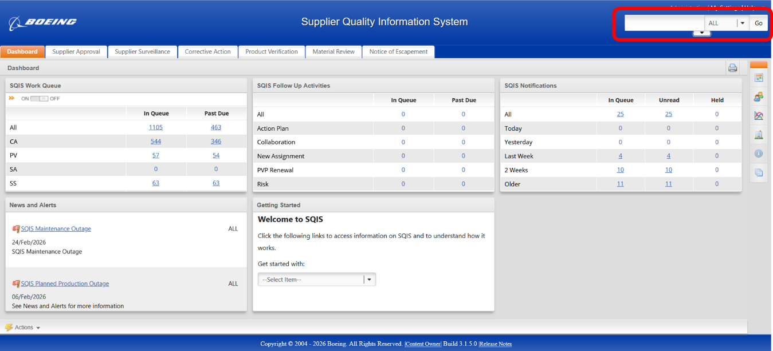
- Open the record and review the NN contents. The record will default to the Profile screen. Ensure you navigate to the “Request” chevron to review the nonconformity information.
  - If you do not access the “Request” chevron, the record will not acknowledge your review.
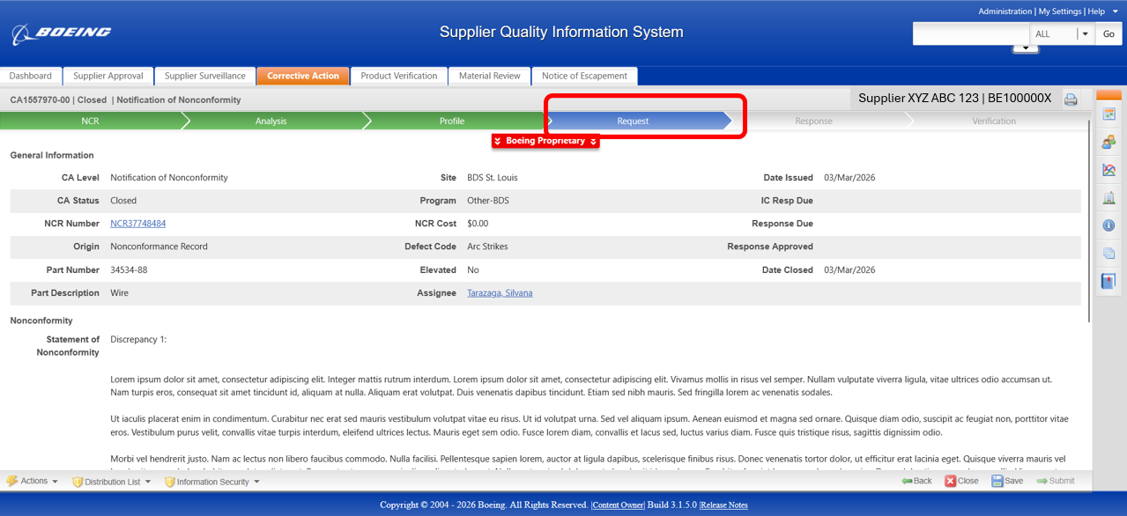

- Save the NN information internally to both prevent accidental loss and to ensure your internal systems are capturing the customer (Boeing) discrepancy information.
  - It is crucial that you perform and maintain internal Corrective Action records relative to all SQIS CA Records, regardless if response is requested.

- Ensure you CLICK THE RED X CLOSE BUTTON when exiting the document in SQIS. This will prevent the record getting temporarily locked for other users upon closure.
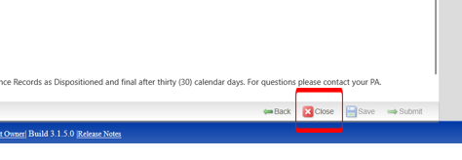

- Post acknowledgement: If needed, use the search bar to locate and return to the record. Alternatively, you can also use the Part Information tool and apply the appropriate filters to locate your record.
Note: SQIS would require the user account to have read access to use the search tools.
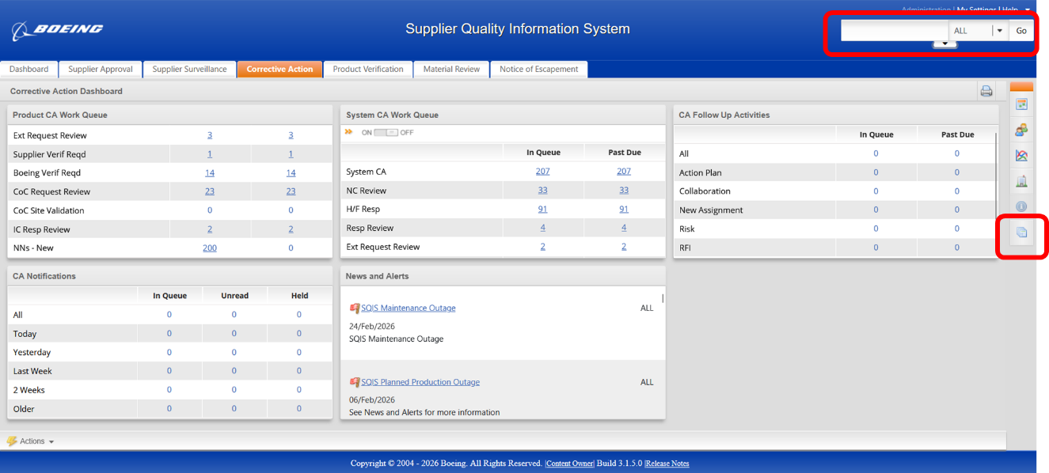
Tools, Resources, and Training:
- Supplier Quality Information System (SQIS) Help, Online Training
- Add link to training when posted to website
- Supplier Corrective Action Response Review (SCARR) Training via the Supplier Portal > Supplier Home > Training > My Learning: SQ000010 training
- As noted, if appropriate supplier personnel do not have SQIS access, contact your Supplier Quality Representative or Boeing Procurement Agent

