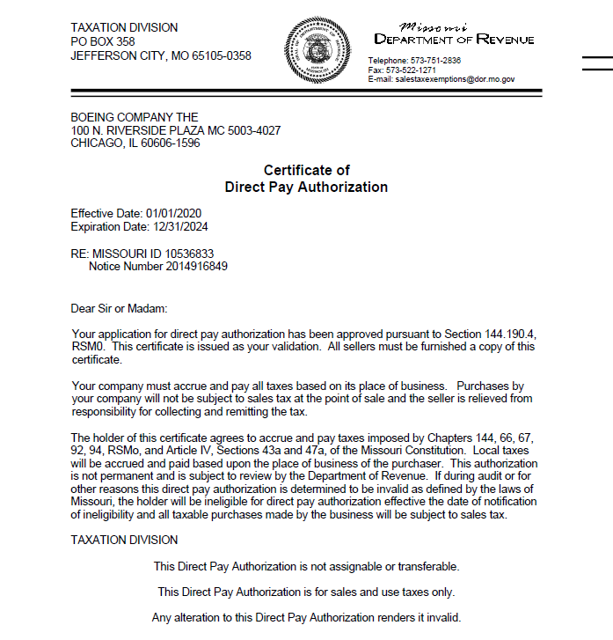

IF YOU HAVE ANY QUESTIONS, PLEASE SEE THE FREQUENTLY ASKED QUESTIONS ON THE BACK
tHE boeing company MISSOURI direct pay certificate

FREQUENTLY ASKED QUESTIONS

- What is a direct pay certificate? This is an agreement between The Boeing Company, (“TBC”), and a taxing jurisdiction, whereby the sales and use tax due to the taxing jurisdiction will NOT be paid to the vendor. Instead, TBC will determine the taxable amount and remit it to the taxing jurisdiction directly.

- What should I do with this certificate? This certificate should be retained in your tax records to support your billings to TBC when your company is audited by the State of Missouri. Upon audit, provide this certificate to the auditors, and the auditors should not review your TBC transactions. (These transactions will be reviewed when the taxing jurisdiction audits TBC.)

- How do I know what Boeing legal entity is purchasing from my company? If you do not know the legal entity that is purchasing products from your company, please refer to the purchase order terms and conditions; the legal entity and its state tax ID number will be listed in the tax clause.

- The ship-to address on your purchase order is different than the address on your certificates which list 100 N Riverside, Chicago Illinois as the TBC address; can I still accept this certificate? YES, the address listed on the certificate is The Boeing Company’s corporate address. All TBC tax documents list this address.

- Do I need a new certificate for every purchase? NO, the attached direct pay certificate is good for all TBC purchases shipped into the State of Missouri; it will expire 12/31/2024.

- My company ships to multiple states can I use this certificate for all the shipments? NO, this certificate is only good for shipments into the State of Missouri. When you ship to another state, you will need to charge tax, unless you have received other supporting documents. If our purchase is annotated as “resale” the tax clause found in our terms and conditions should contain the necessary information to claim this exemption in many states.

- I receive orders from other Boeing legal entities; can I use this certificate for those orders? NO, this certificate is only good for purchases made by TBC.

- I no longer do business with TBC, should I keep this certificate? YES, for two reasons; first, to support your previous tax free shipments to TBC. And second, if you plan to do business with TBC in the future, you will already have this certificate in your file.

- Do you have other TBC Direct Pay Certificates? YES, other certificates for the states of Alabama, Arizona, Florida, South Carolina, Texas and Washington are available upon request, please contact Dennis Moeller at dennis.g.moeller@boeing.com.

If you have any other questions please contact Dennis Moeller at dennis.g.moeller@boeing.com

